CST8912 – Cloud Solution Architecture
Graded Lab Activity #9
Introduction: Microsoft Azure provides a comprehensive suite of tools to protect data according to an organization’s security and compliance requirements. One fundamental aspect of data security is encryption at rest, which ensures that data stored in Azure services is protected against unauthorized access and physical threats. Azure SQL Database, in particular, includes robust security features such as encryption, data classification, and auditing to help safeguard sensitive data and meet regulatory standards. This lab focuses on exploring these features to enhance the security and data privacy of an Azure SQL Database.
Objective: The main objective of this lab is to understand and implement the security features offered by Microsoft Azure for an Azure SQL Database. By completing this lab, you will:
- Deploy an Azure SQL Database.
- Configure advanced data protection mechanisms to defend against SQL injection and data exfiltration.
- Implement data classification to identify and organize data into categories, such as Confidential.
- Set up auditing to monitor database activities and log events for security and compliance.
- Clean up resources after completing the lab.

Instructions:
Task 1: Deploy an Azure SQL Database
Method 2:
In the Azure portal, in the Search resources, services, and docs text box at the top of the Azure portal page, type Deploy a custom template and press the Enter key.
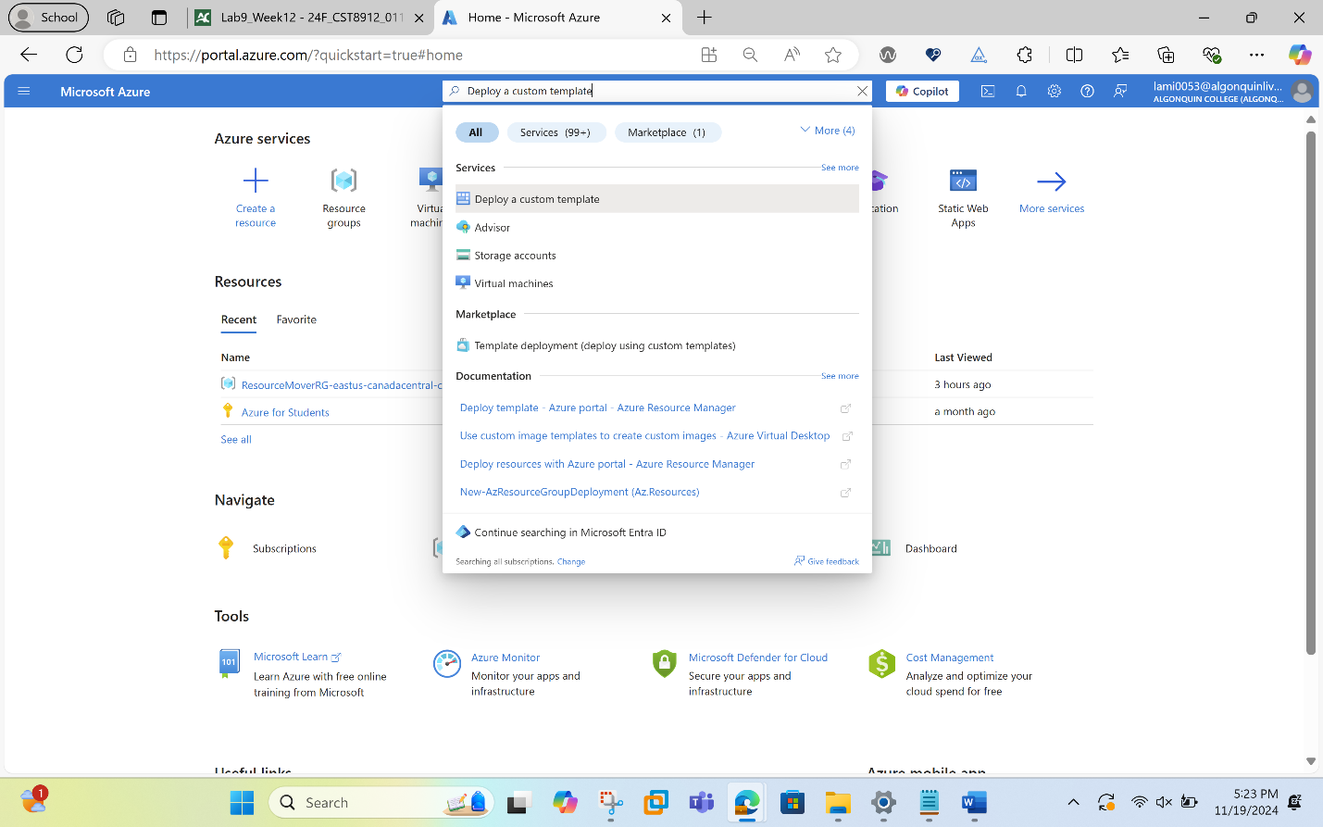

On the Custom deployment blade, click the Build your own template in the editor option.
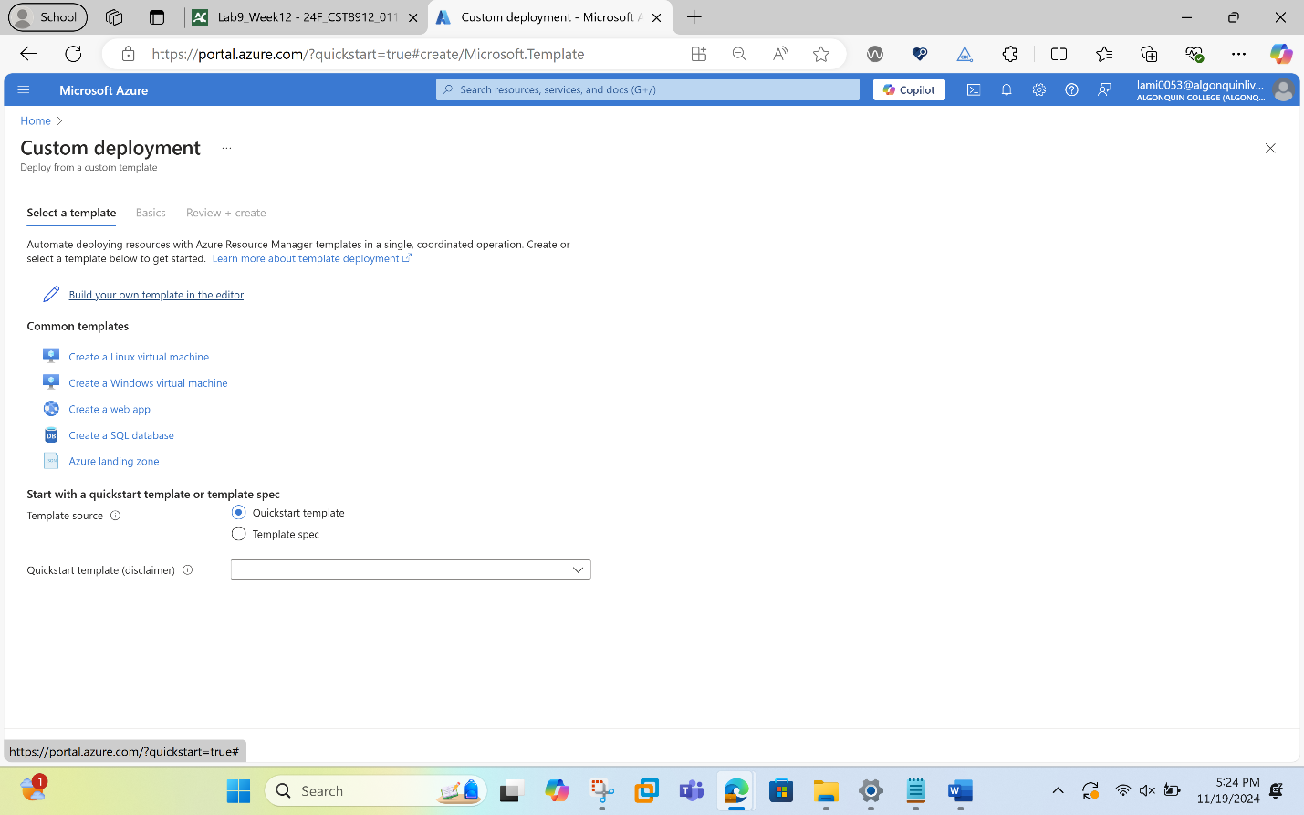
On the Edit template blade, click Load file , locate the https://github.com/MicrosoftLearning/AZ500-AzureSecurityTechnologies/blob/master/Allfiles/Labs/11/azuredeploy.json file and click Open.
In this step, we changed the location to canadacentral.

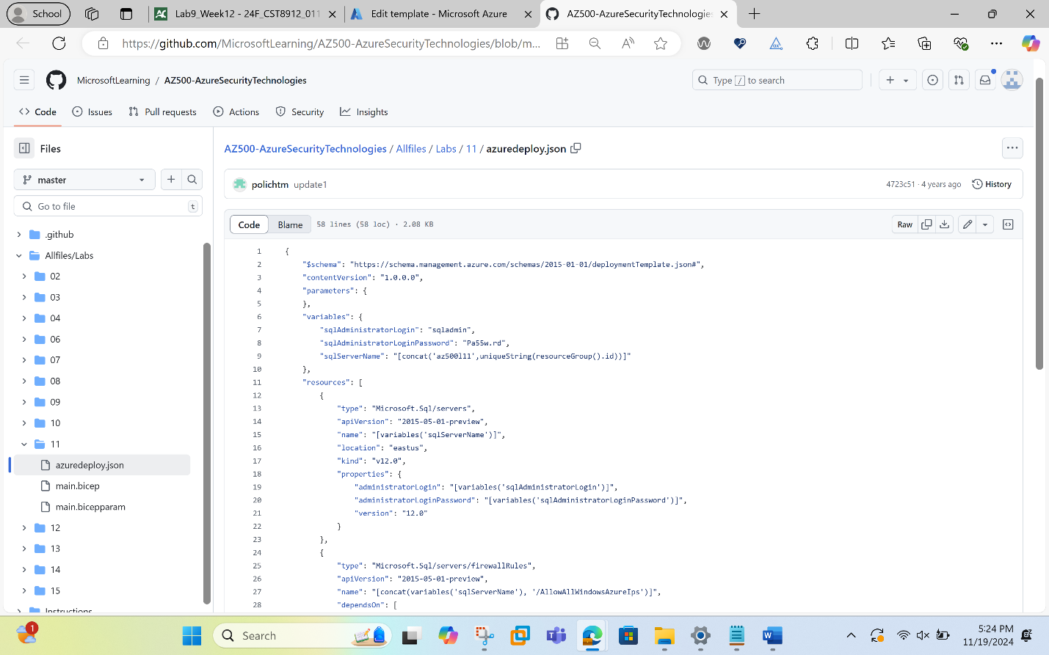
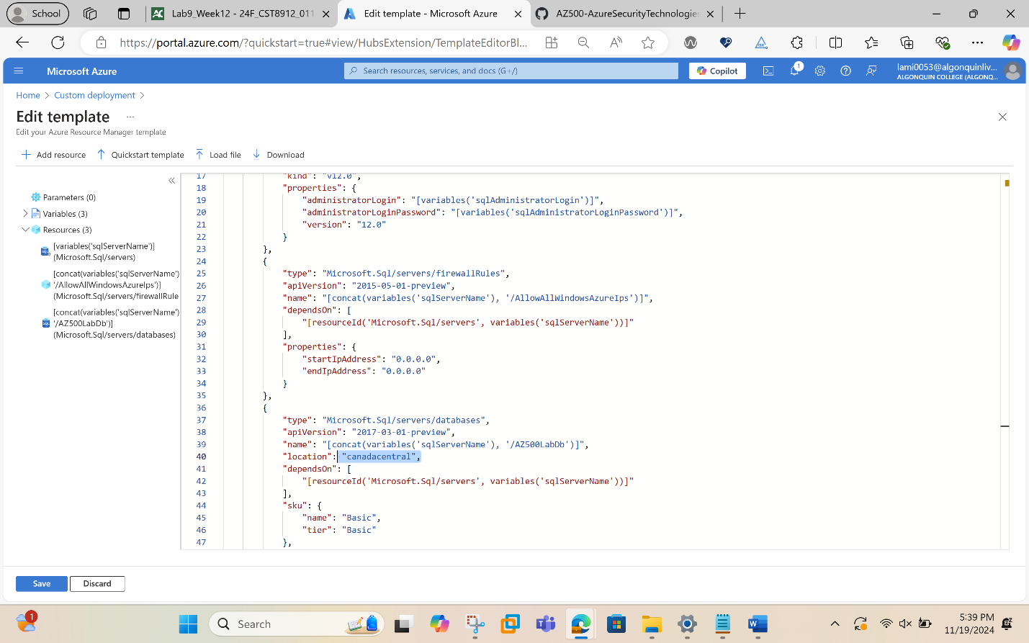

On the Edit template blade, click Save.
On the Custom deployment blade, ensure that the following settings are configured (leave any others with their default values):
Setting | Value
Subscription | Azure subscription
Resource group | CST8912
Location | Canada Central

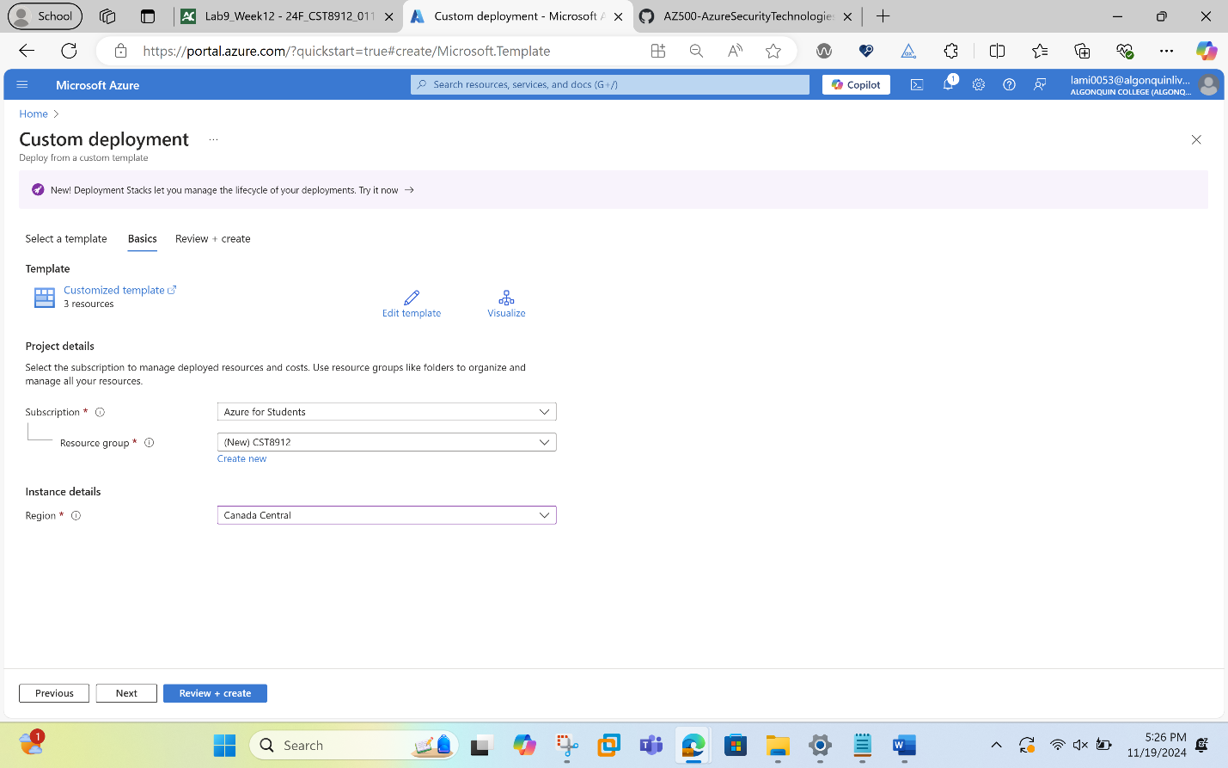

Click Review + Create and then click Create.
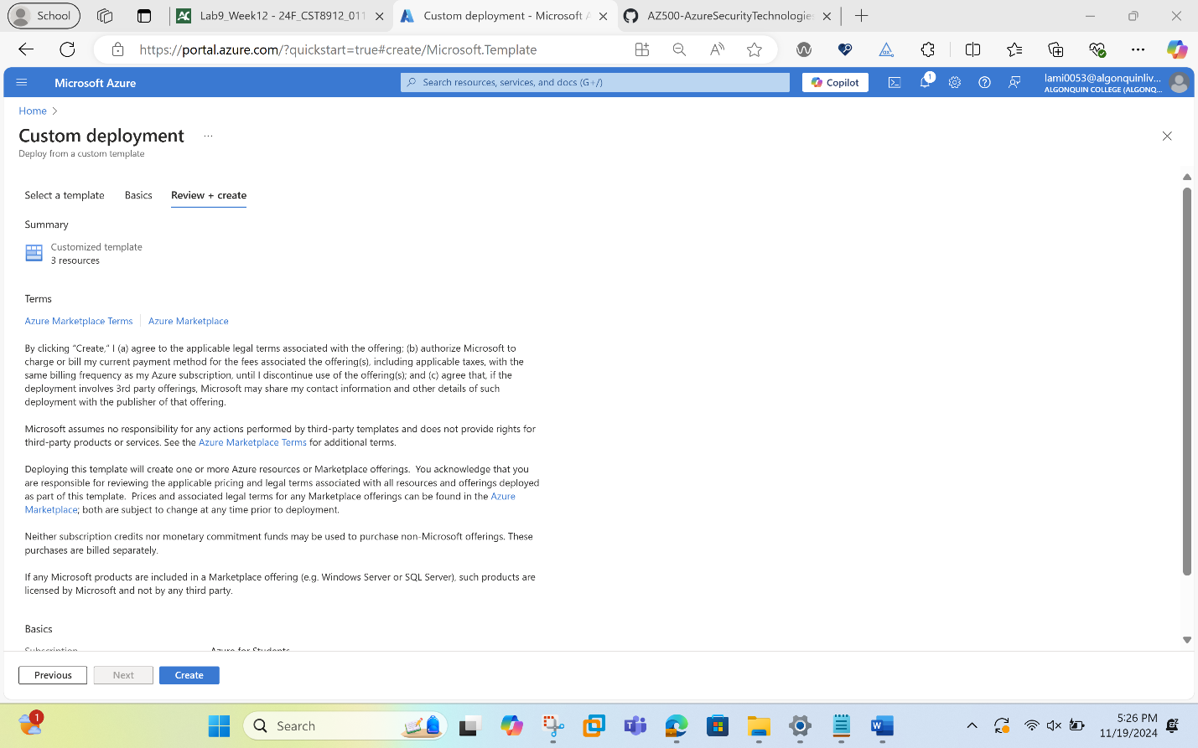
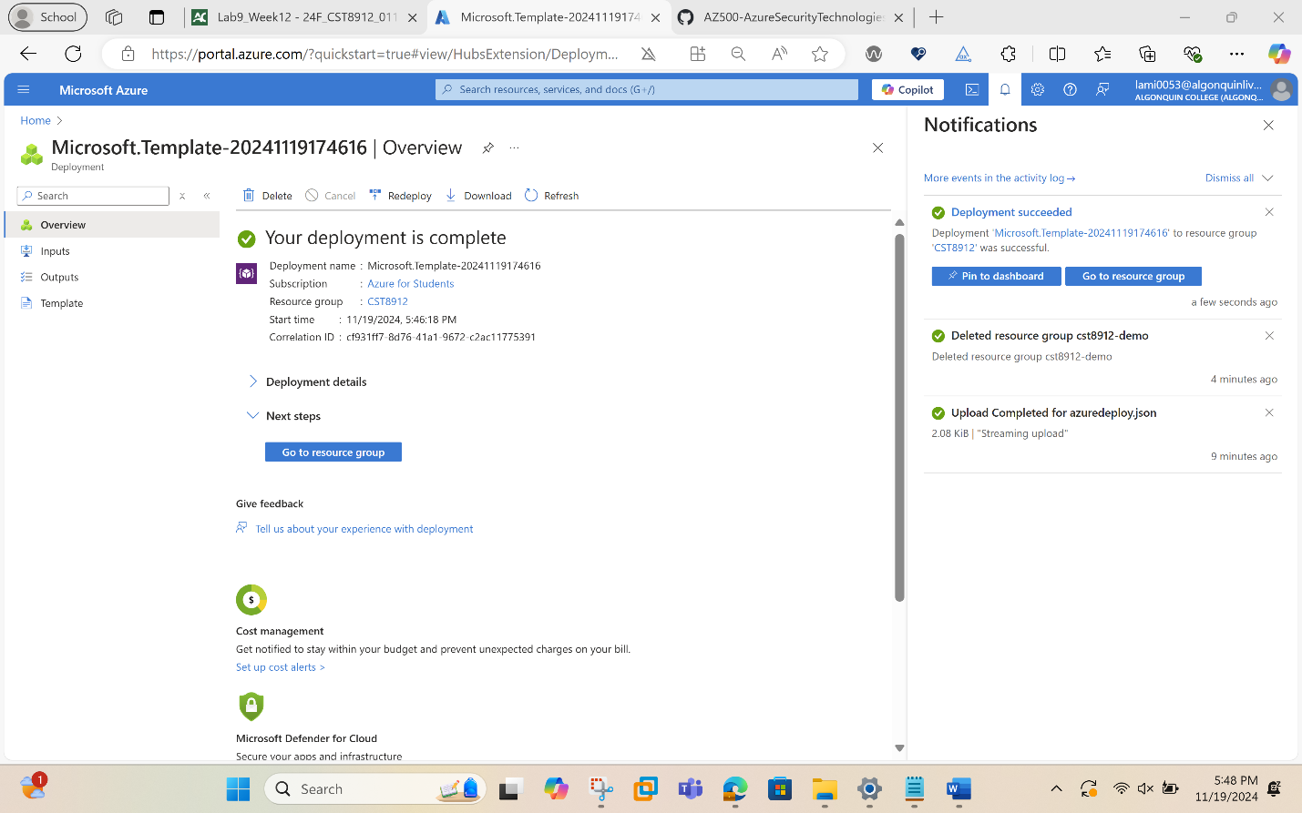
Task 2: Configure Advanced Data Protection
On the SQL server blade, in the Security section, click Microsoft Defender for Cloud, select Enable Microsoft Defender for SQL.
On the SQL server blade, in the Security section, on the Microsoft Defender for Cloud page, in the Microsoft Defender for SQL: Enabled at the subscription-level (Configure) parameter, click (configure)
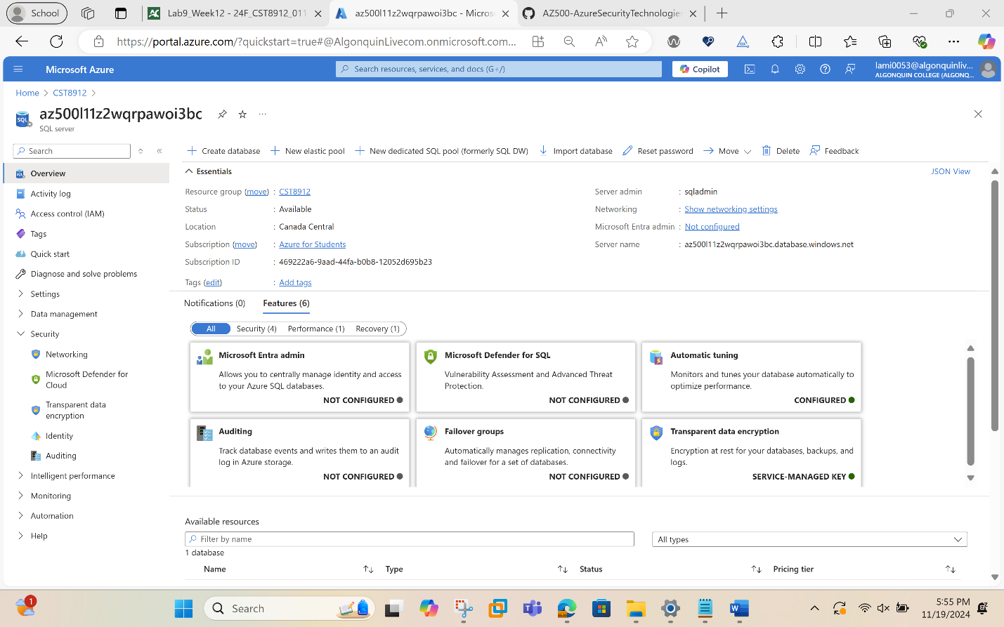
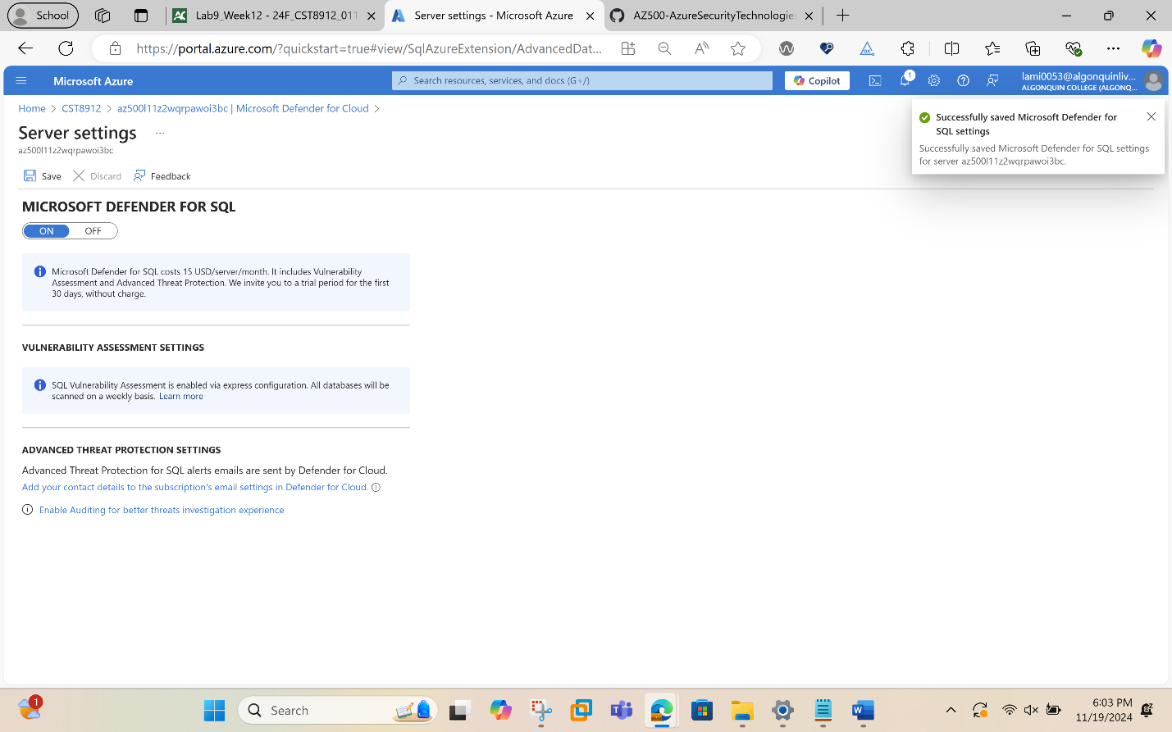
On the Server Settings blade, review the information about pricing and the trial period, VULNERABILITY ASSESSMENT SETTINGS and ADVANCED THREAT PROTECTION SETTINGS.
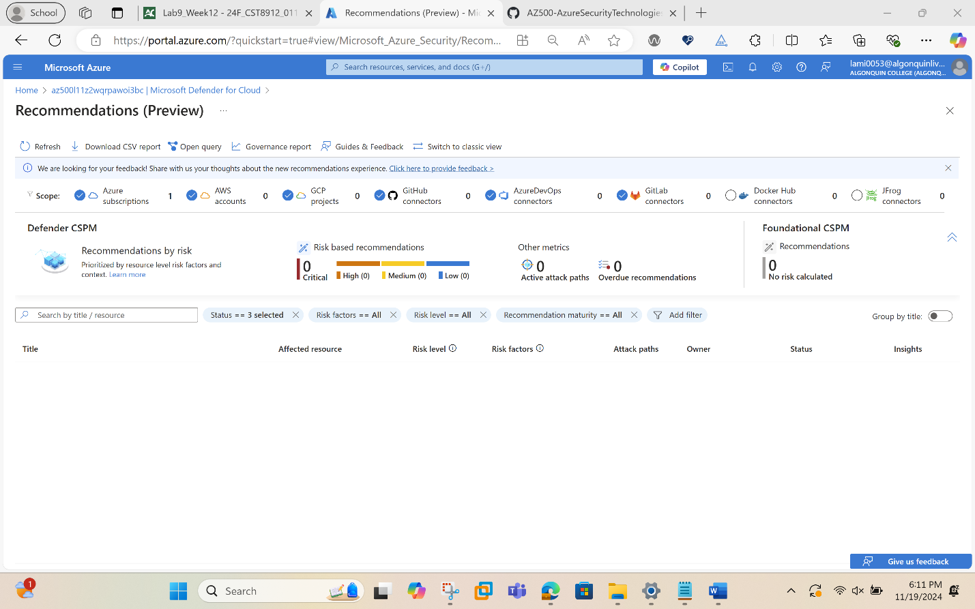
Back to Microsoft Defender for Cloud blade, review Recommendations and Security alerts.
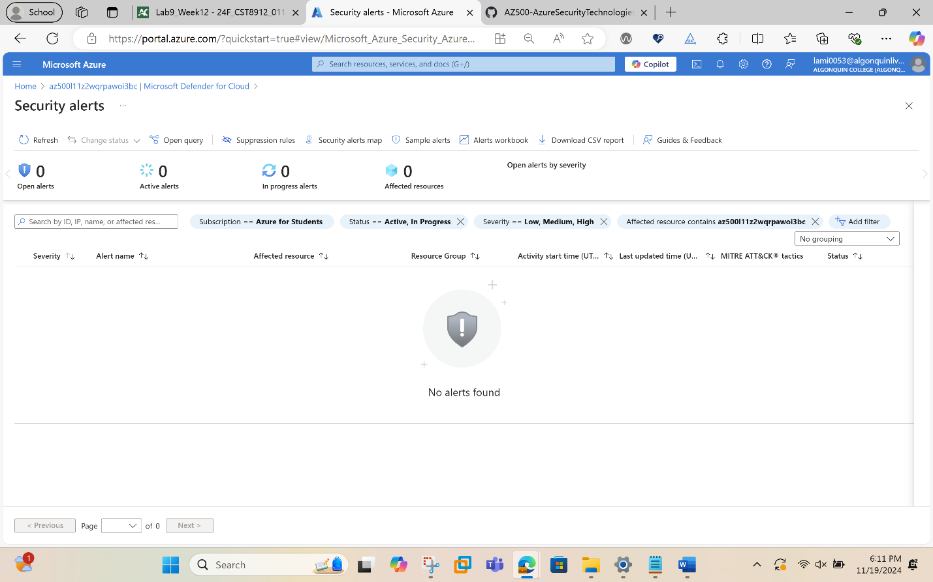
Task 3: Configure Data Classification
In this task, you will explore and classify data in SQL database for GPDR and data protection compliance.
On the SQL server blade, in the Settings section, click SQL Databases.
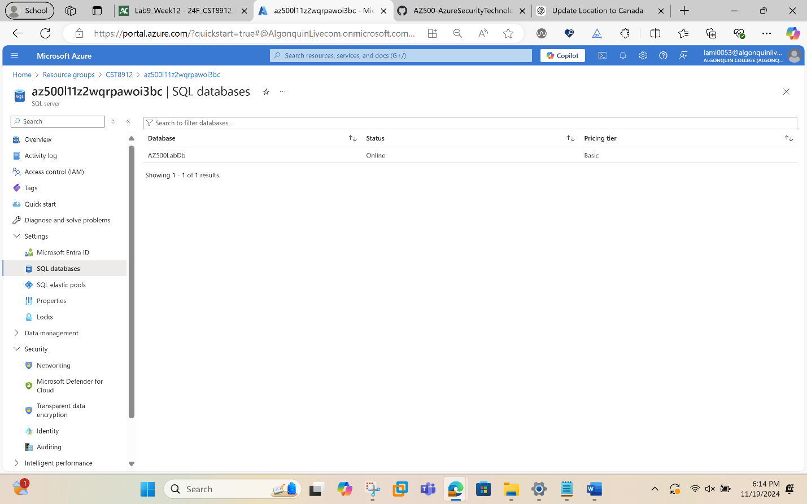
On the SQL database blade, in the Security section, click Data Discovery & Classification.
On the Data Discovery & Classification blade, click the Classification tab.
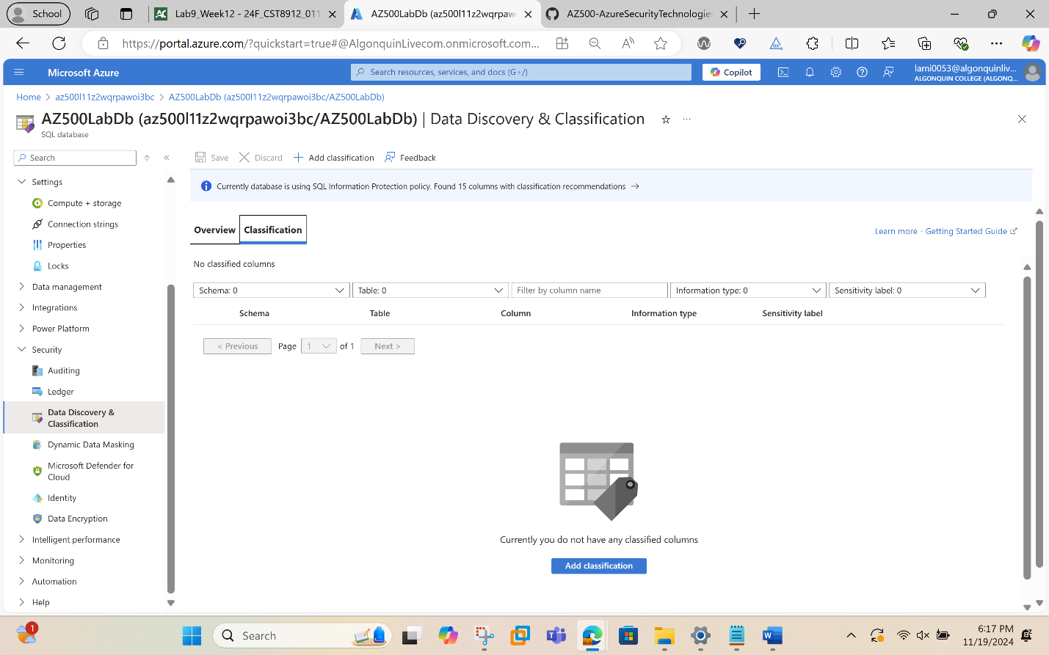
Click the text message We have found 15 columns with classification recommendations displayed on blue bar at the top of the blade.
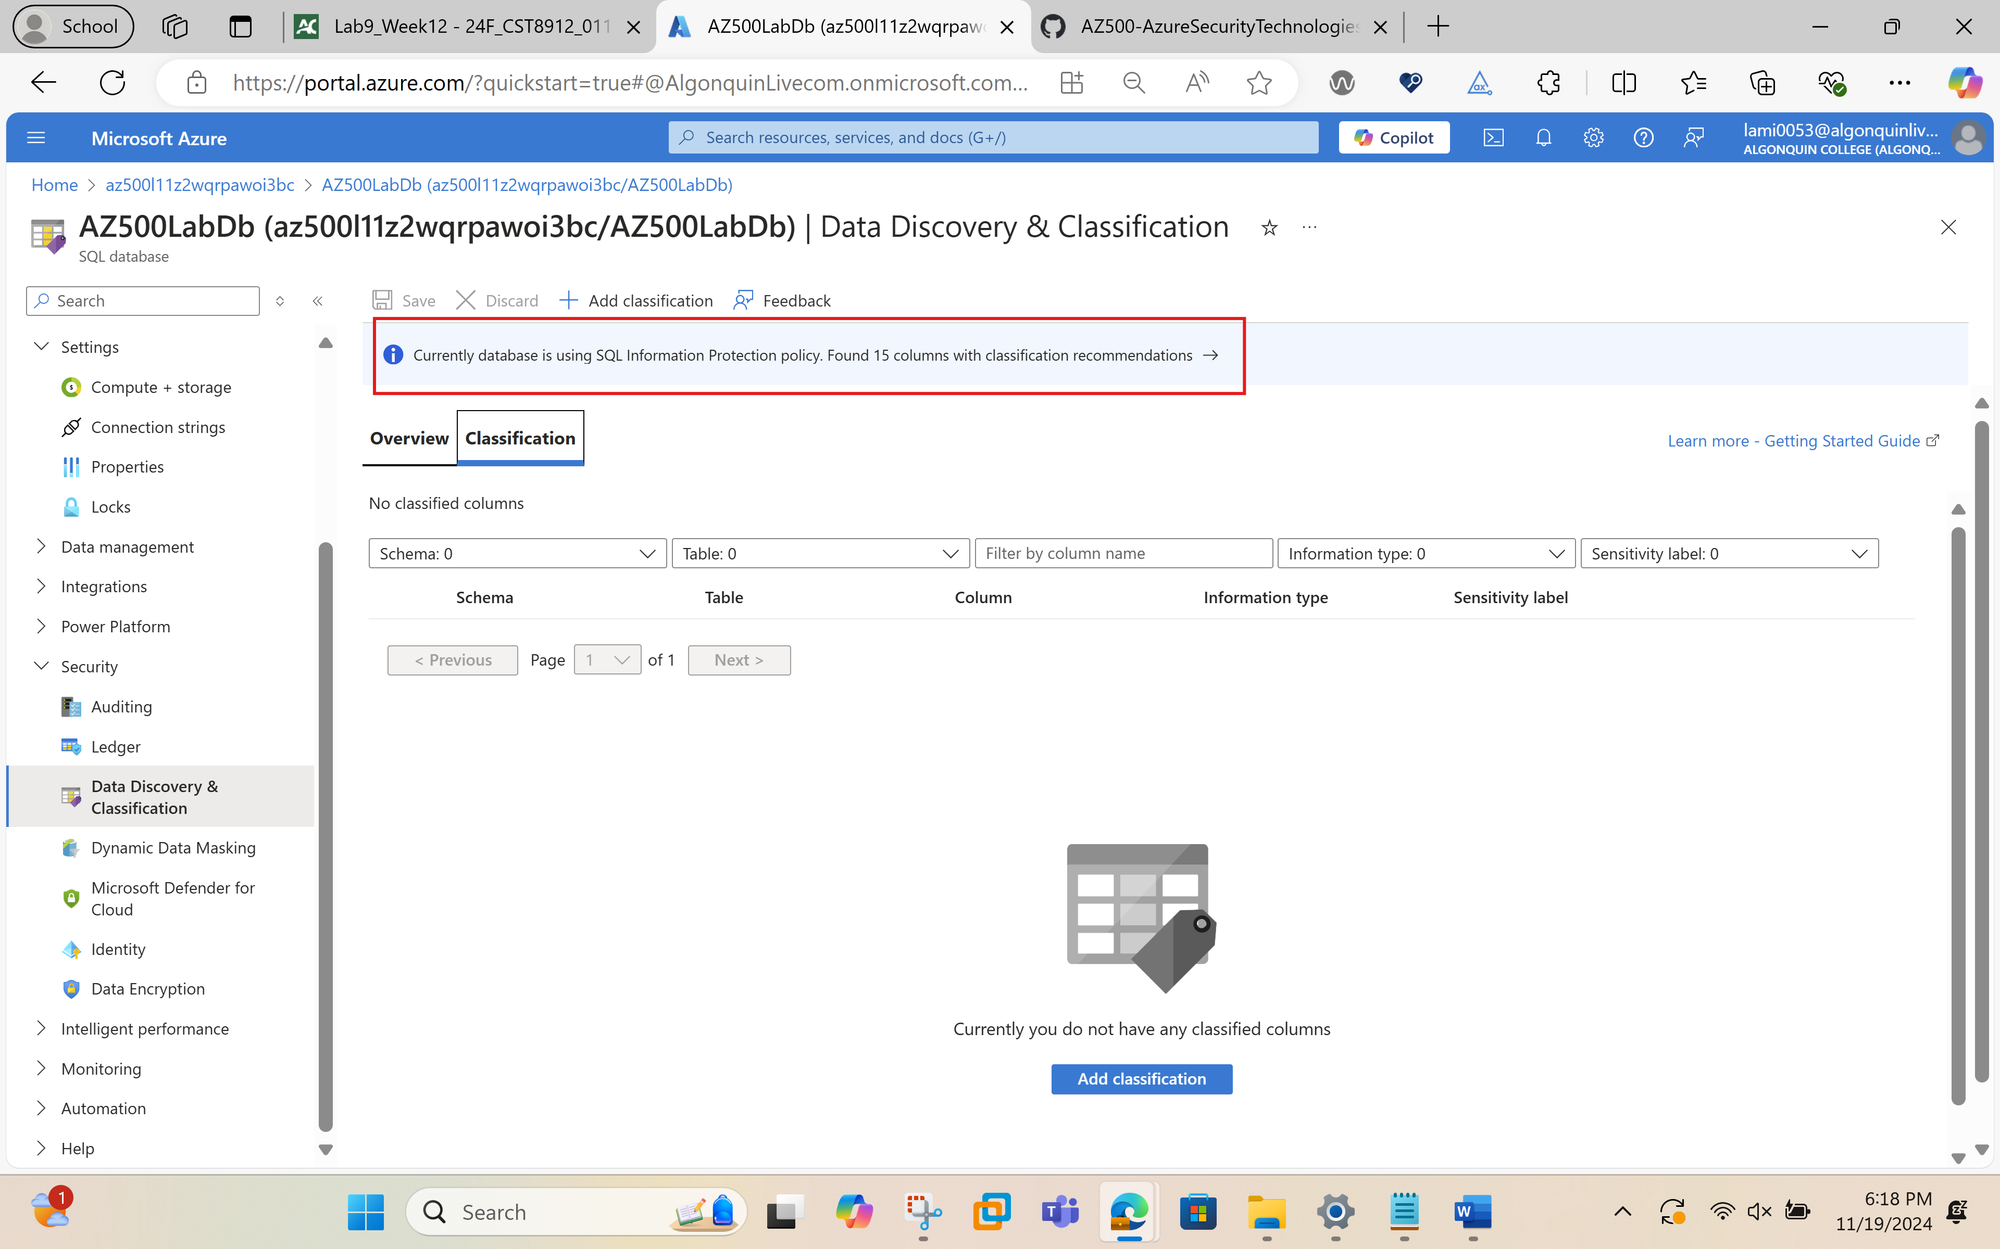
Review the listed columns and the recommended sensitivity label.
Enable the Select all checkbox and then click Accept Selected Recommendations.
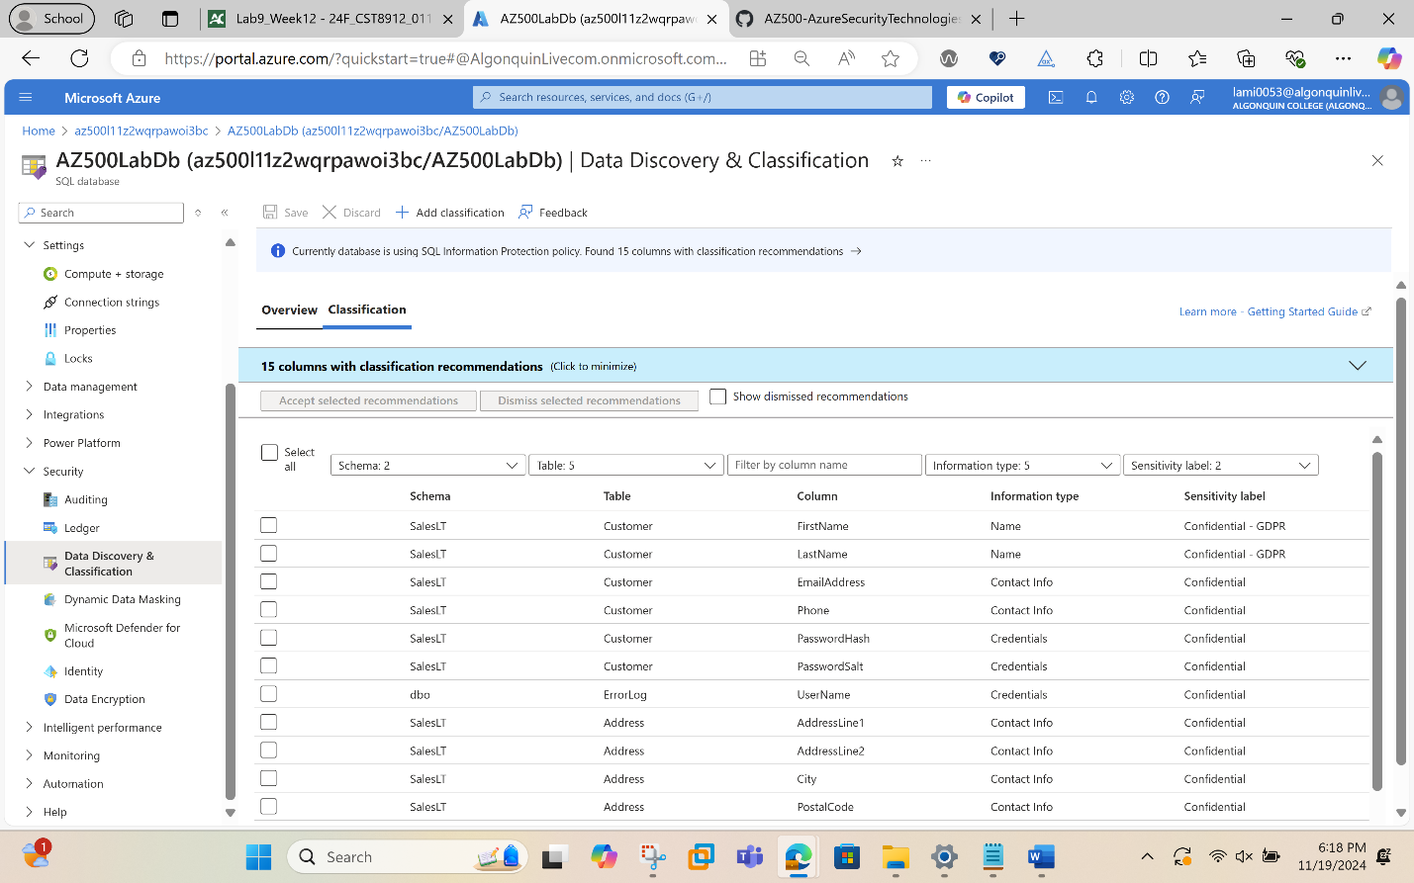
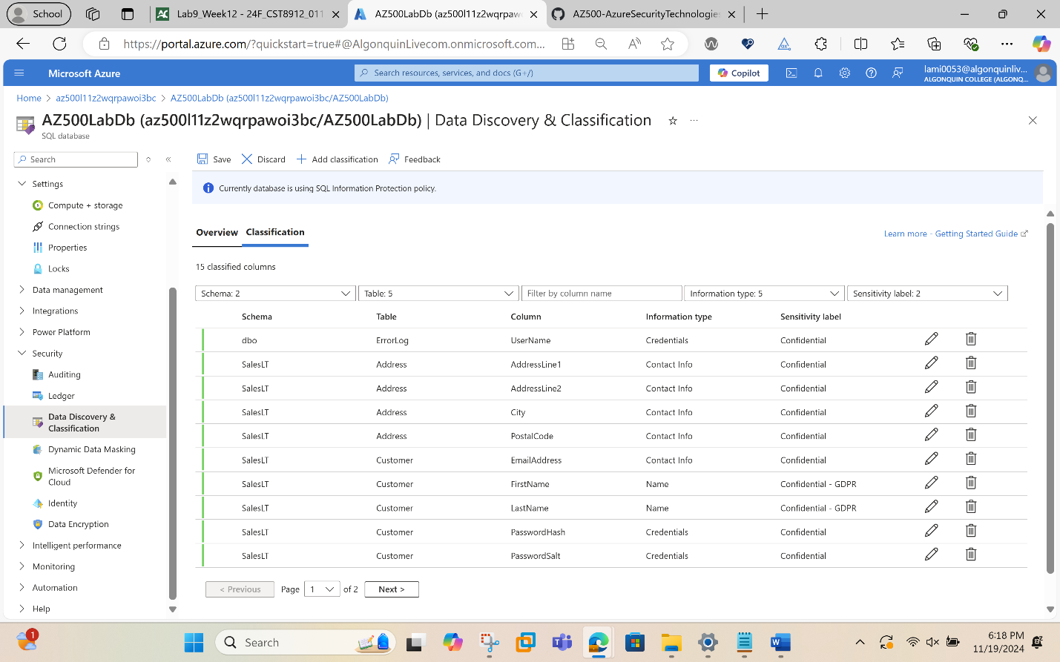

Once you have completed your review click Save.
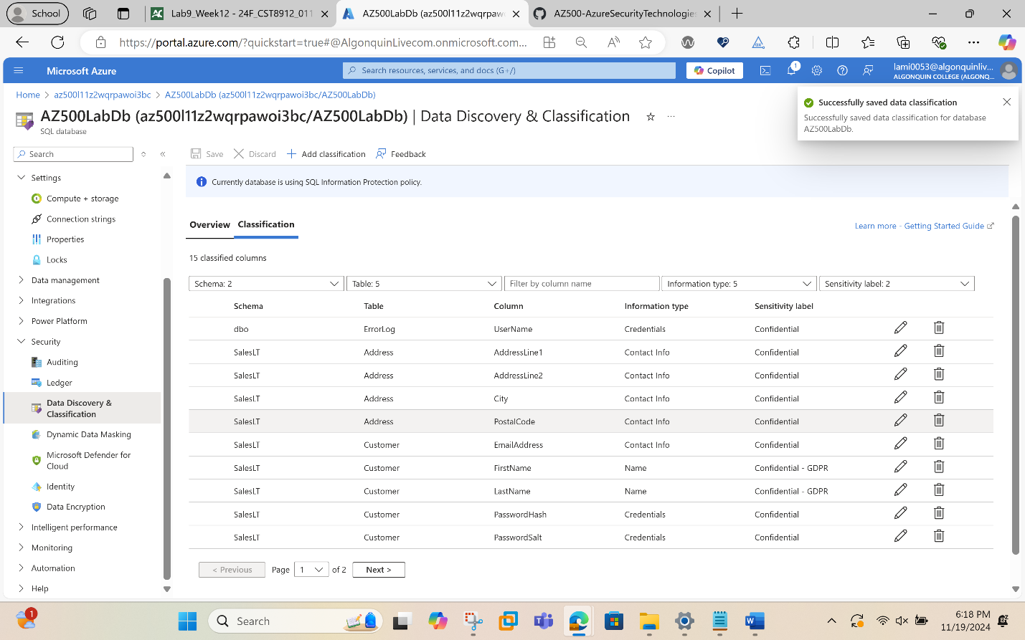
Back on the Data Discovery & Classification blade Overview tab, note that it has been updated to account for the latest classification information.
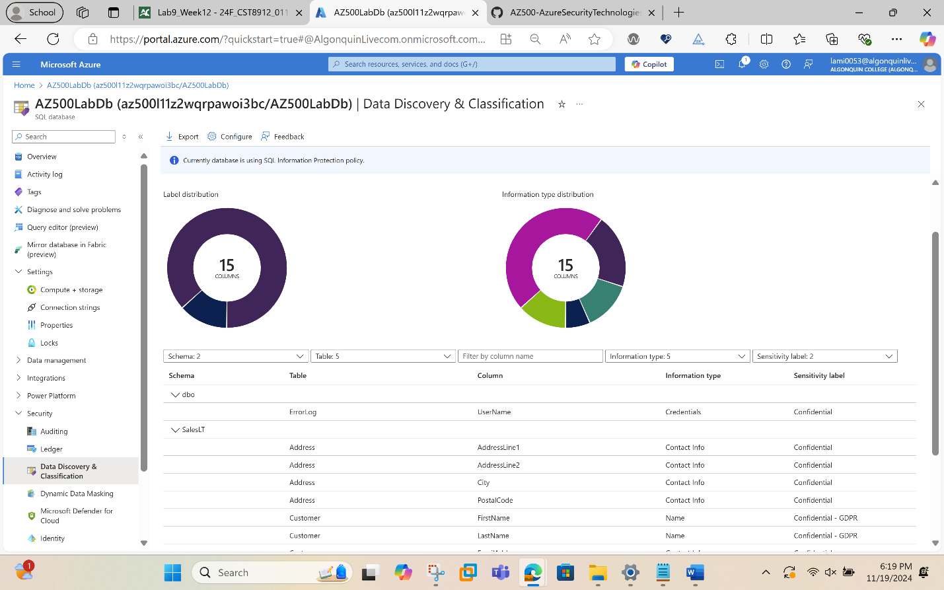
Task 4: Configure Auditing
In this task, you will first configure server level auditing and then configure database level auditing.
In the Azure portal, navigate back to the SQL Server blade.
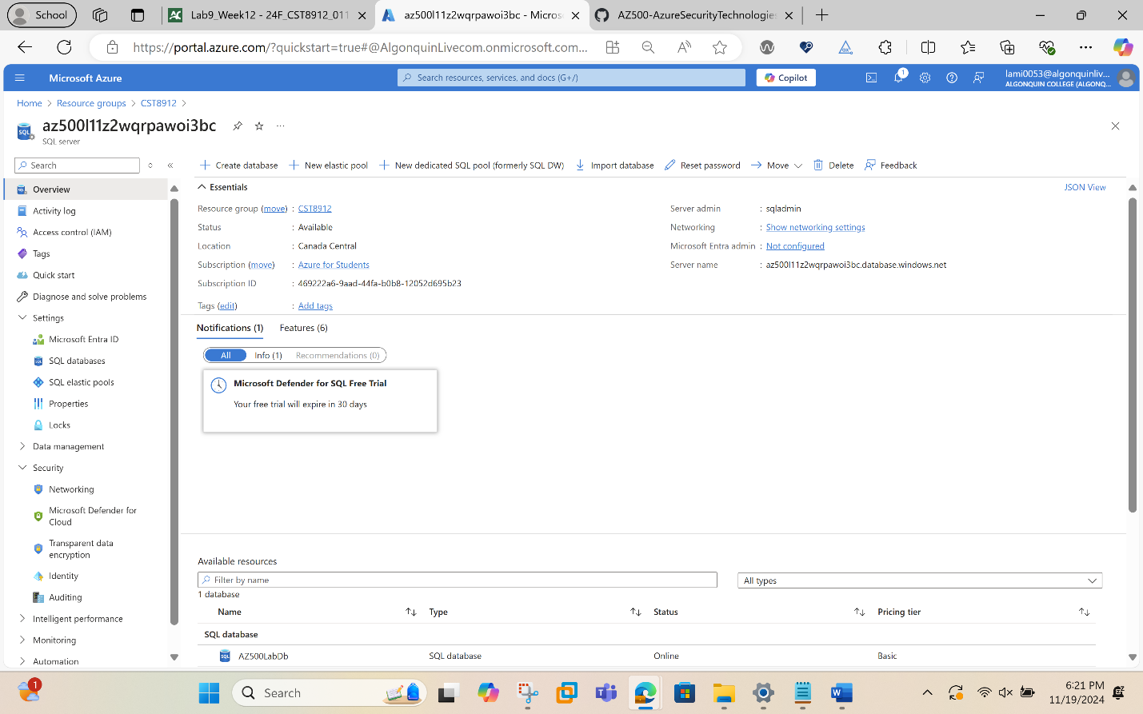
On the SQL Server blade, in the Security section, click Auditing.
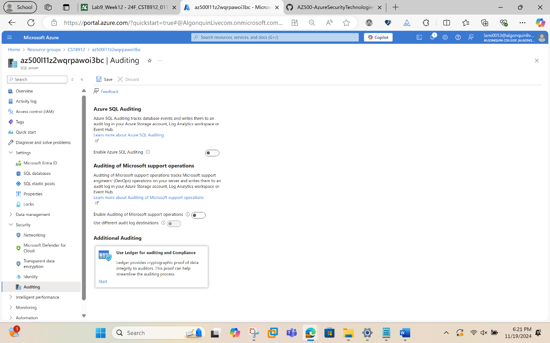

Set the Enable Azure SQL Auditing switch to ON to enable auditing
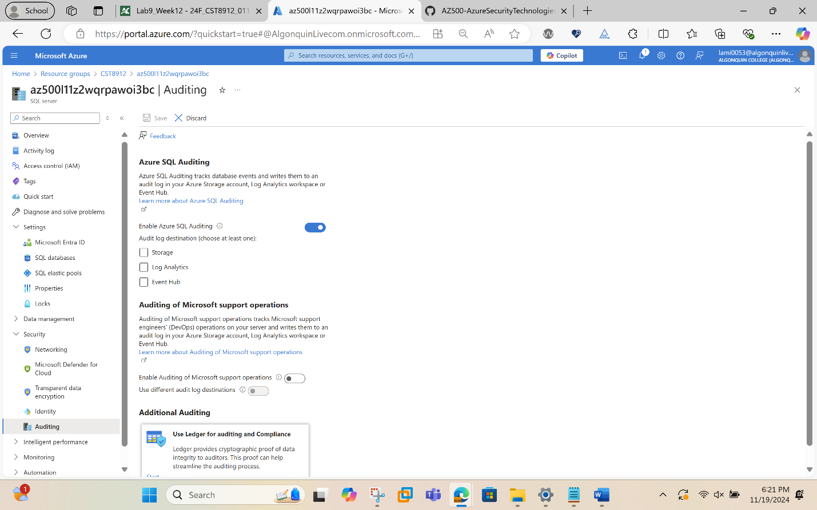
Select the Storage checkbox and entry boxes for Subscription and Storage Account will display (create new storage account if not selected)
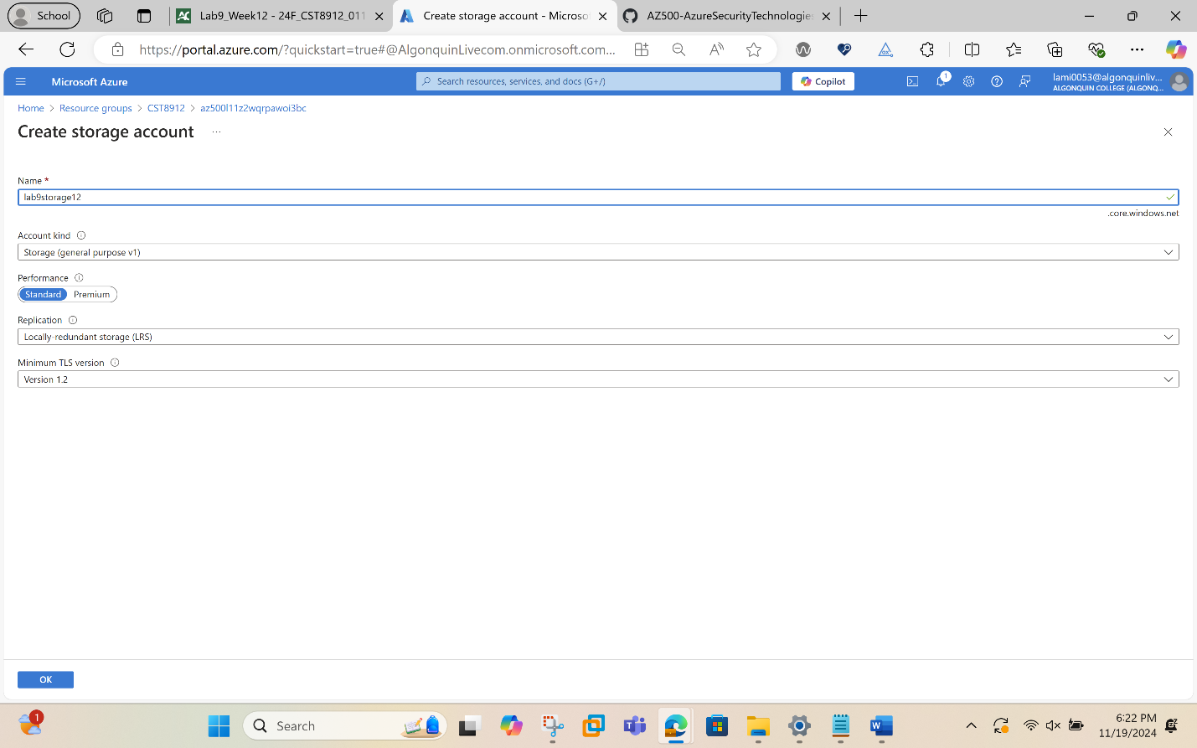
Choose your Subscription from the dropdown list.
Click Storage account and choose Create new.
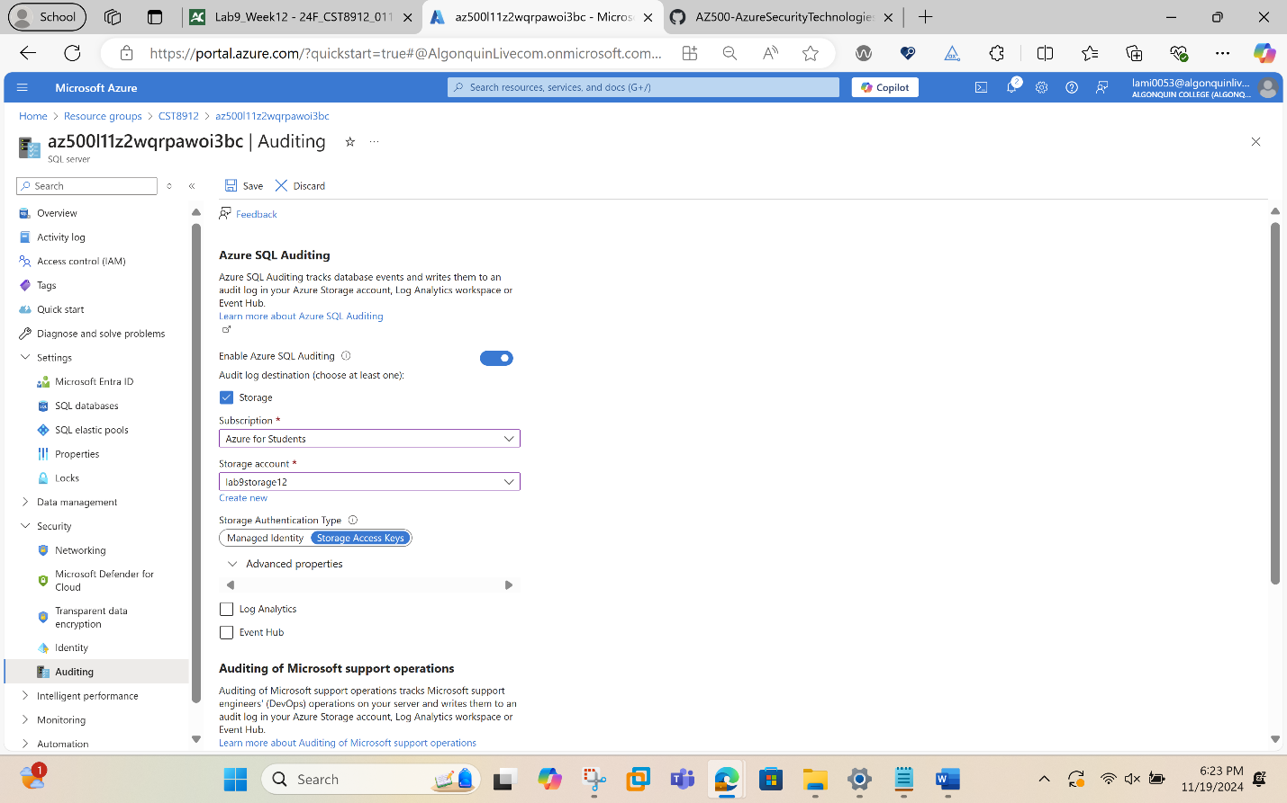
Back on the Auditing blade, under Advanced properties set Retention (days) to 5.
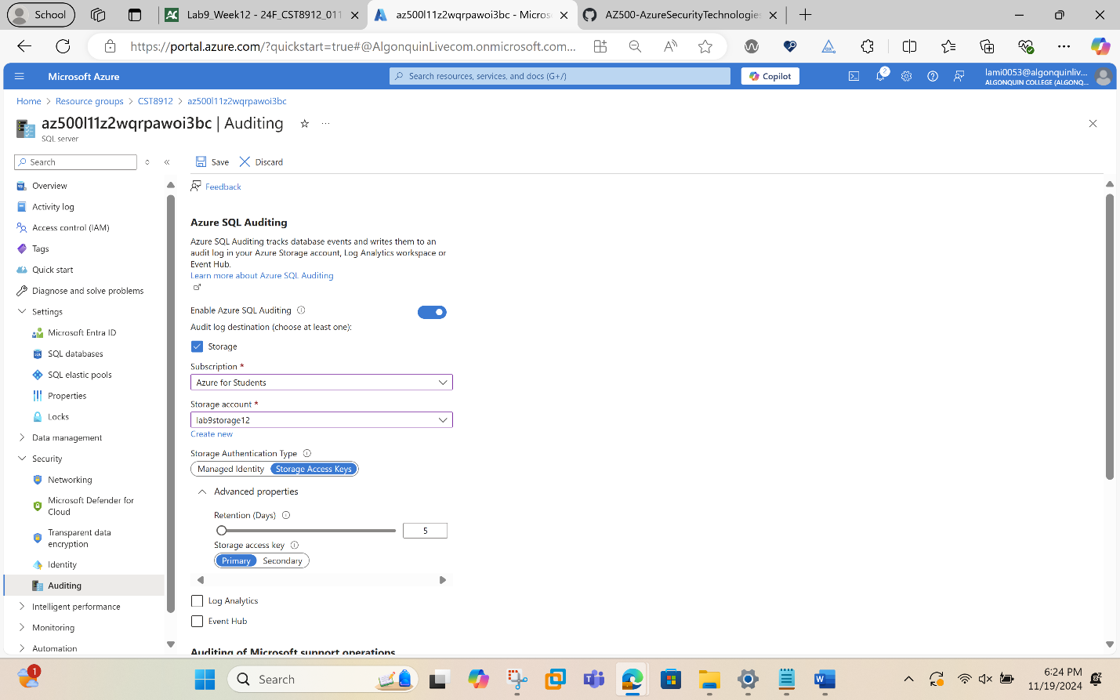
On the Auditing blade, click Save to save the auditing settings.
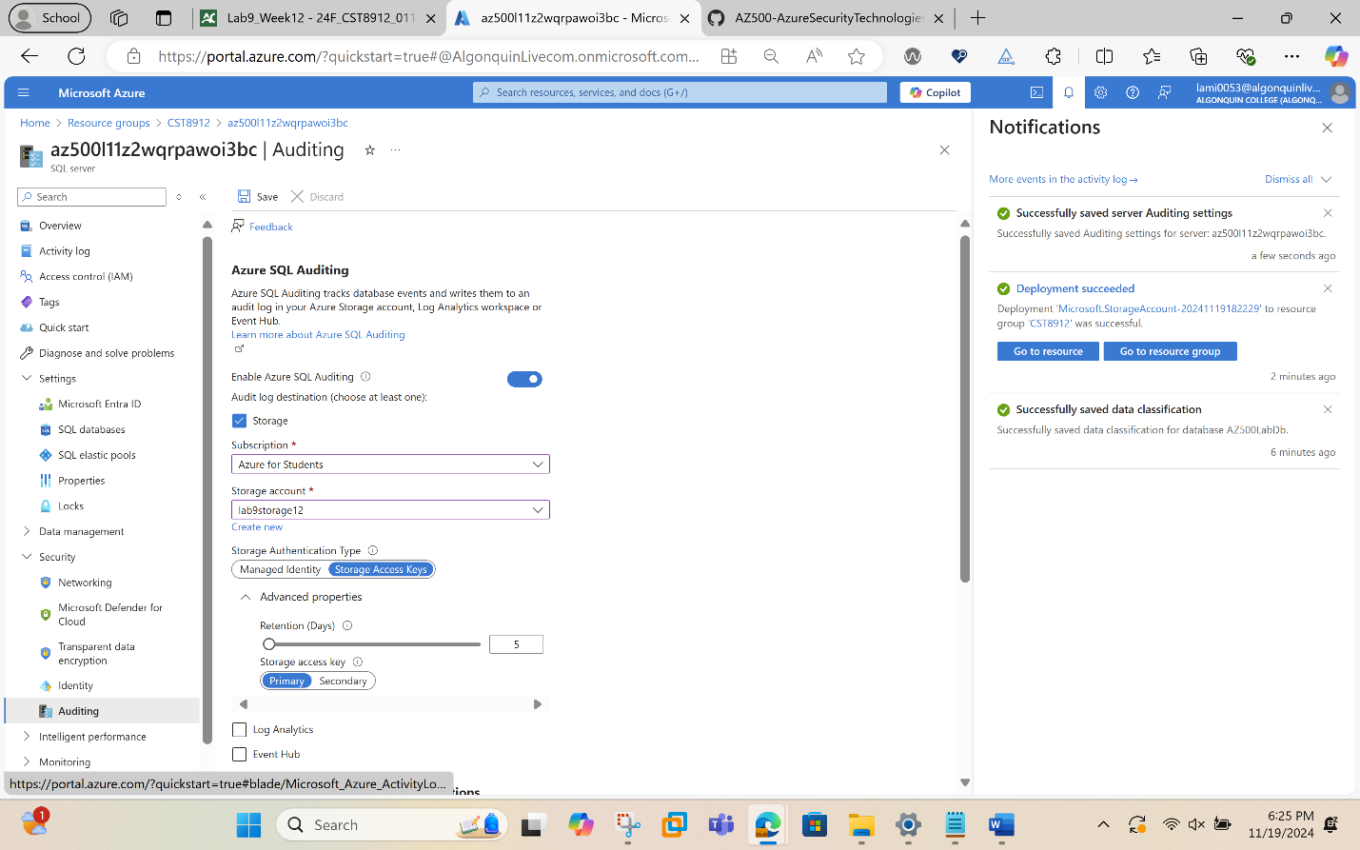
On the server blade, in the Settings section, click SQL Databases.
On the SQL database blade, in the Security section, click Auditing.
Note: This is database level auditing. Server-level auditing is already enabled.
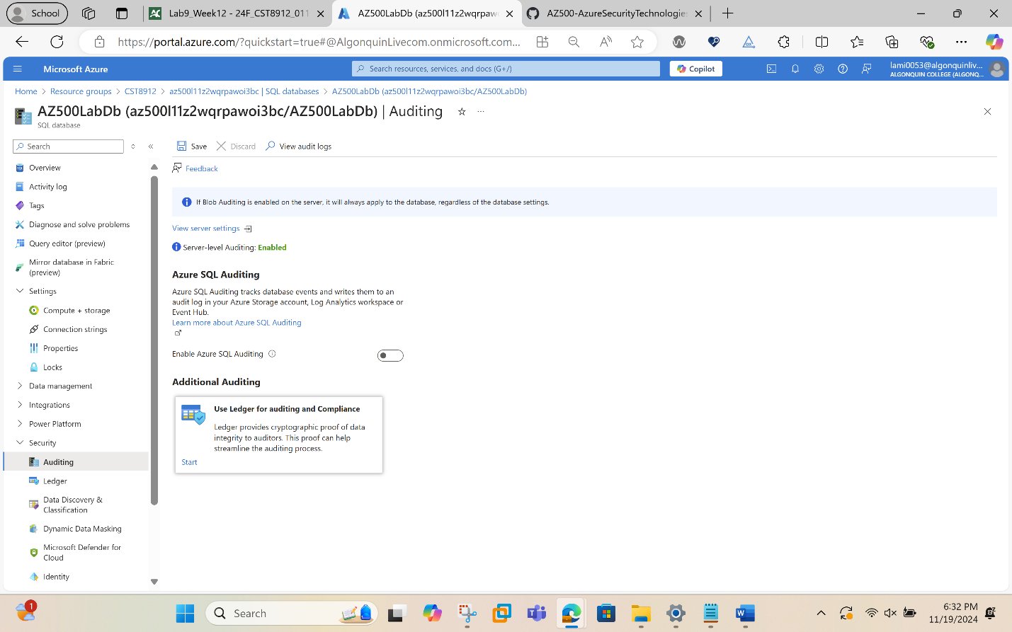
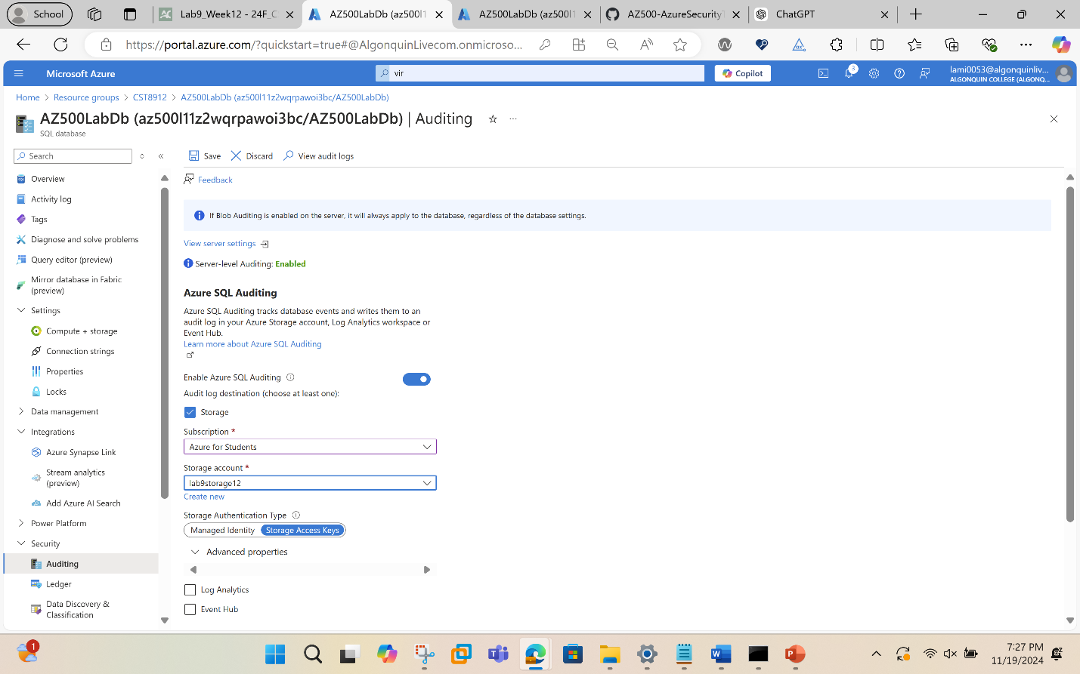

On your SQL database Overview page in the Azure portal, select Query editor (preview) from the left menu. Try to sign in, you might fail on password, firewall rule for your IP address, everything gets audited. Try successful login as well, run query and you might find more details in audit logs.
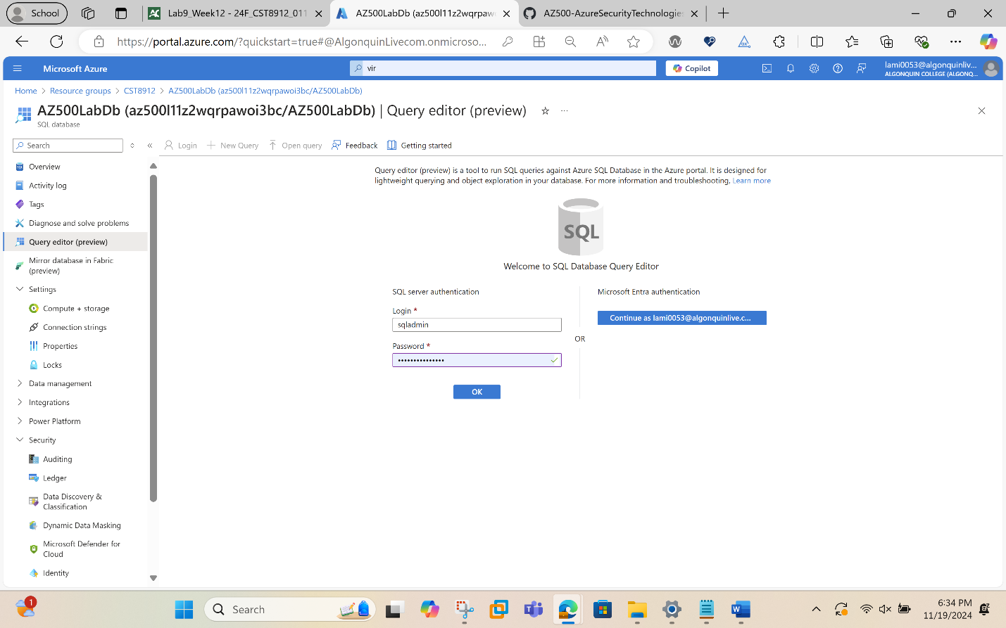
We then assigned ip address.
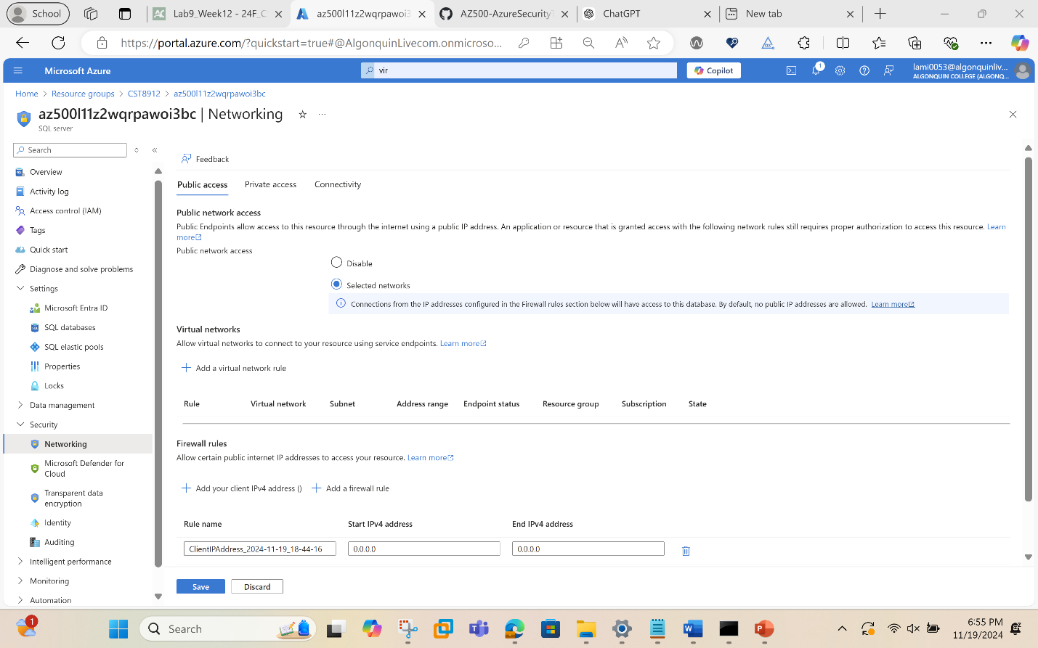
We could then login to query editor.
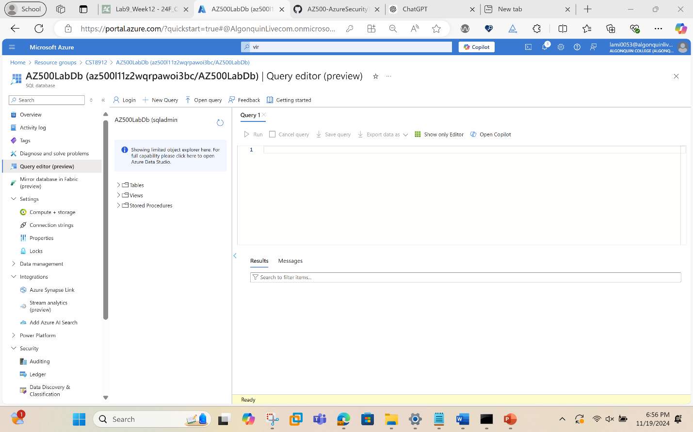
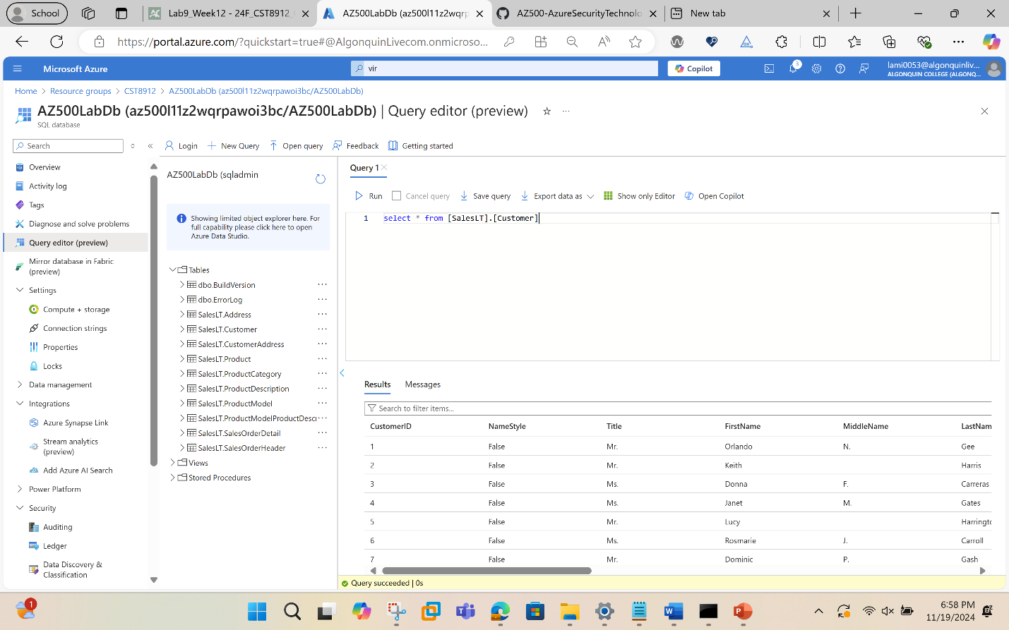
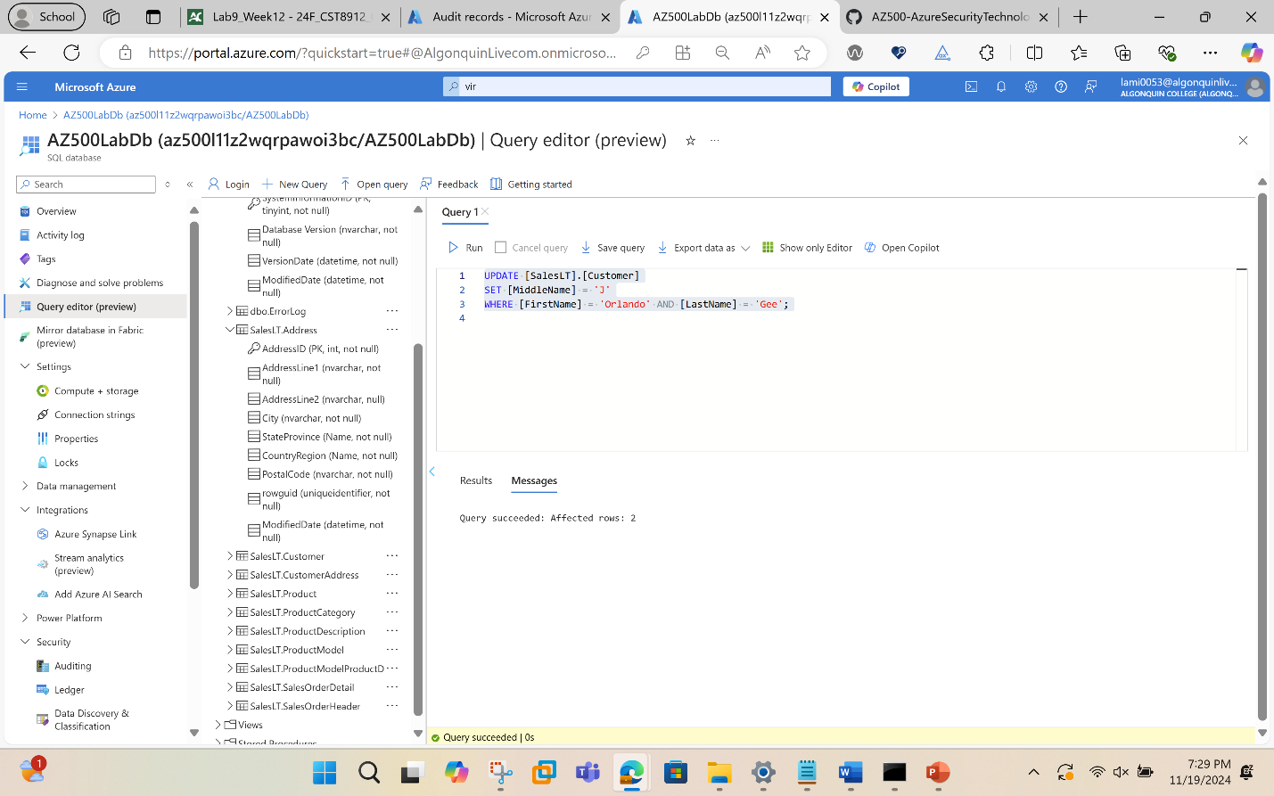

switch back to DB, Auditing and Click View Audit Logs.
On the Audit records blade, note that you can switch between Server audit and Database audit.
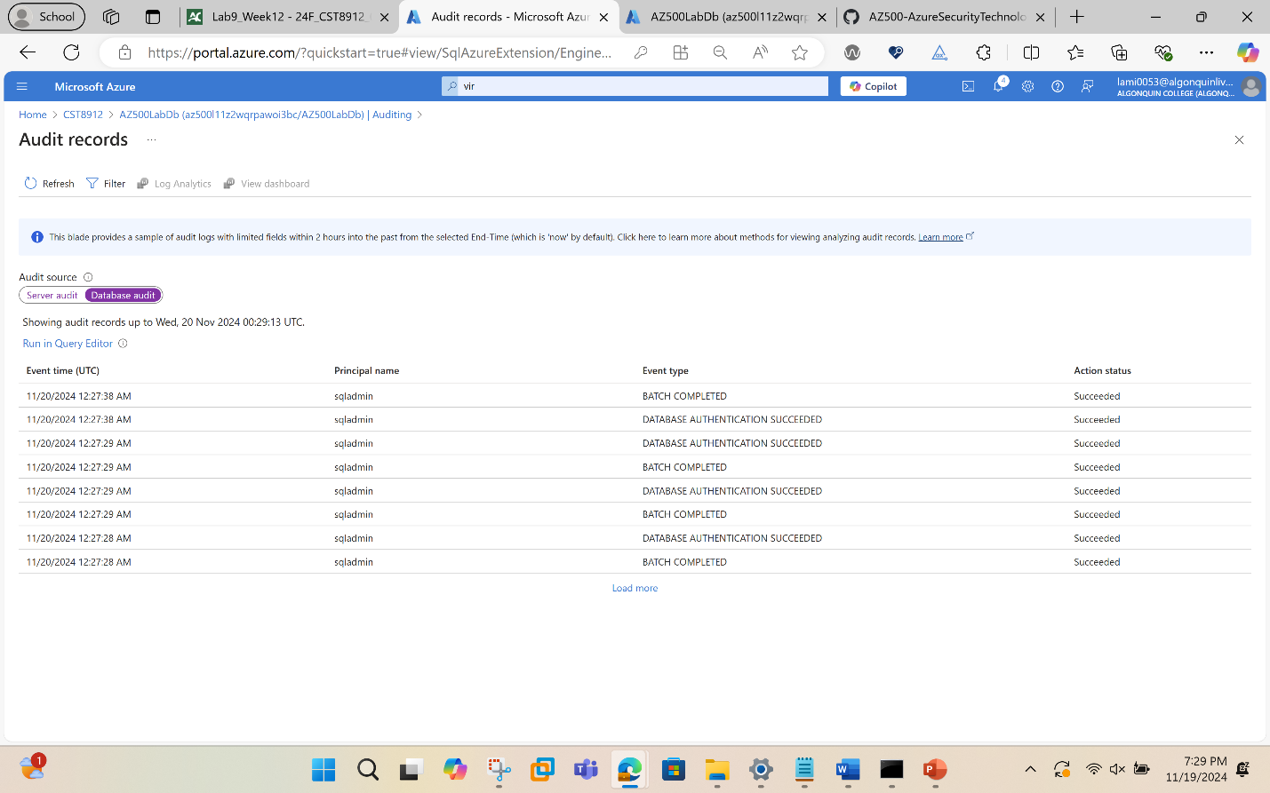
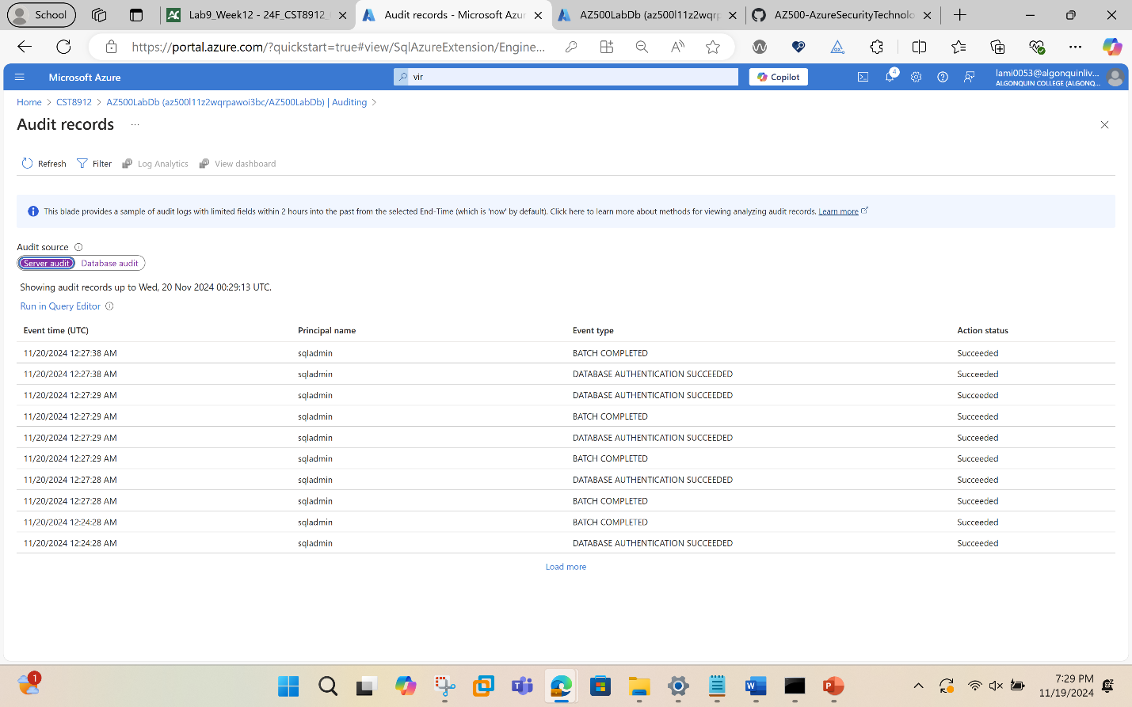
Task 5: Clean up resources created during this lab
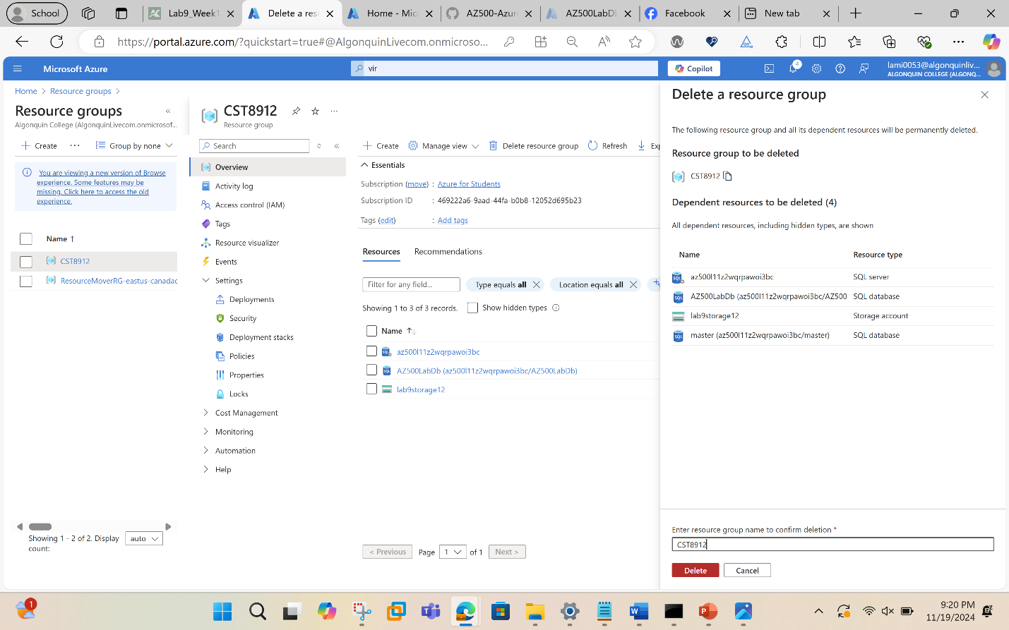
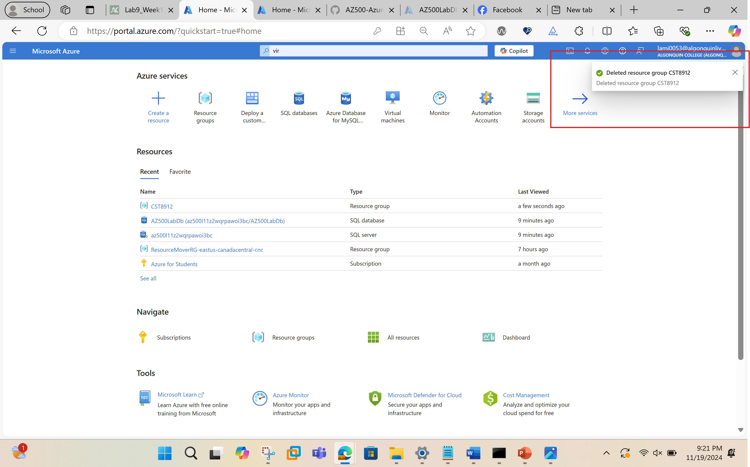
This step then concludes the lab.
Conclusion: This lab provides hands-on experience with key security features in Azure SQL Database, including advanced data protection, data classification, and auditing. These practices are essential for maintaining the privacy and integrity of client data, ensuring compliance, and enhancing the overall security posture of cloud-based database solutions.

